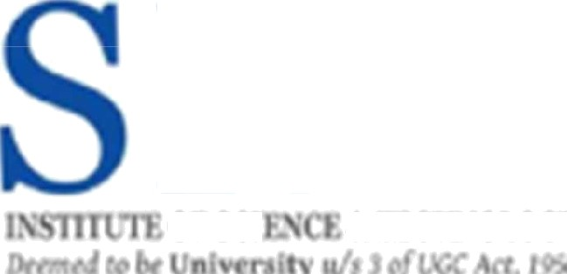

LIBRARY MANAGEMENT

21CSS101J - PROGRAMMING FOR PROBLEM SOLVING

Mini Project Report

Vijay Sachin M [RA2211003010028] B.Tech. CSE-Core

Hemanth Kumar[RA2211003010006] B.Tech. CSE-Core



SCHOOL OF COMPUTING

COLLEGE OF ENGINEERING AND TECHNOLOGY SRM TNSTITWE OF SCIENCE ANB TECHNOLOGY

(Under Section 3 of UGC 4c$ 19S6)

S.RM. NAGA@ KATTANKULATHUR - 603 203

KANCHEEPURAM DISTRICT

December 2022

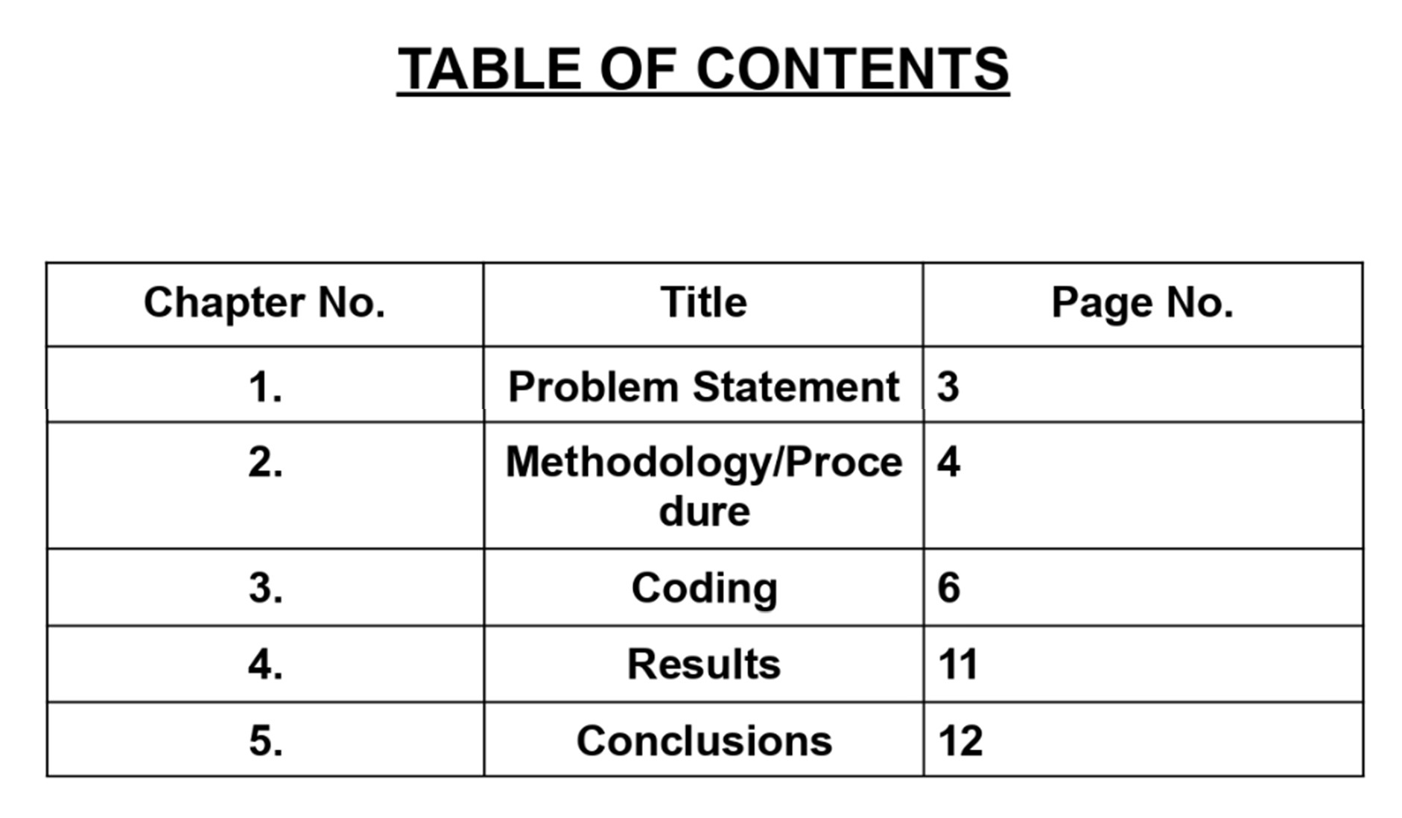

**5**

**7**

**9**

# PROBLEM STATEMENT :-

A library database system is an infrastructure that allows users to search for books, request a book, add /return a book and exit the library.

The problem faced is that library users require an efficient method to find specific books or keywords within a book giving a continuously expanding library. It is an important piece of software that should be there in all

schools and colleges.

This software makes work easier and helps to find the book in the library without any work or manual search.

If a student or staff wants a book to be added. It can also be possible with the request option.

A person can search for a book in an option of thousands of books.

Students can also exit the library with the option in code.

# PROCEDURE:-

In this code, we have used different types of classes i.e. Class library, and Class student.

Classes are created by keyword class.

Attributes are the variables that belong to a class.

Attributes are always public and can be accessed using the dot (.) operator. Eg.: Myclass, My attribute

In this code, we have also used functions.

Functions are blocks of code written to carry out a specified task. There are two types of functions in python: User-Defined Functions - these types of functions are defined by the user to perform any specific task. Built-in Functions - these types of functions are pre-defined in python.

And we have used ifelse and elif to find the result of the program. The result of the program are-List all the books, Request a book, Add/Return a book, and Exit a book.

# CODE:-

class Library:

def init (self, listOfBooks): self.books = listOfBooks

def displayAvailableBooks(self):

print("Books present in this library are: ") for book in self.books:

print(" *" + book)

def borrowBook(self, bookName): if bookName in self.books:

print(f"You have been issued {bookName}. Please keep it safe and return it within 30 days")

self.books.remove(bookName) return True

else:

print("Sorry, This book is either not available or has already been issued to someone else. Please wait until the book is available")

return False

def returnBook(self, bookName): self.books.append(bookName)

print("Thanks for returning this book! Hope you enjoyed reading it.

Have a great day ahead!")

class Student:

def requestBook(self):

self.book = input("Enter the name of the book you want to borrow: ") return self.book

def returnBook(self):

self.book = input("Enter the name of the book you want to return: ") return self.book

if __name == " main ":

centraLibrary = Library(["Algorithms", "Django", "Clrs", "Python Notes"]) student = Student()

# centraLibrary.displayAvailableBooks() while(True):

welcomeMsg = '''\n ====== Welcome to Central Library ====== Please choose an option:

1. List all the books
2. Request a book
3. Add/Return a book
4. Exit the Library ''' print(welcomeMsg)

a = int(input("Enter a choice: ")) if a == 1:

centraLibrary.displayAvailableBooks() elif a == 2:

centraLibrary.borrowBook(student.requestBook()) elif a == 3:

centraLibrary.returnBook(student.returnBook()) elif a == 4:

print("Thanks for choosing Central Library. Have a great day

ahead!")

exit()

else:

print("Invalid Choice!")

# RESULT:-

====== Welcome to Central Library ====== Please choose an option:

1. List all the books
2. Request a book
3. Add/Return a book
4. Exit the Library

Enter a choice: 1

Books present in this library are:

*Algorithms

*Django

*Clrs

*Python Notes

====== Welcome to Central Library ====== Please choose an option:

1. List all the books
2. Request a book
3. Add/Return a book
4. Exit the Library

Enter a choice: 2

Enter the name of the book you want to borrow: Clrs

You have been issued Clrs. Please keep it safe and return it within 30 days

====== Welcome to Central Library ======

Please choose an option:

1. List all the books
2. Request a book
3. Add/Return a book
4. Exit the Library

Enter a choice: 3

Enter the name of the book you want to return: Clrs

Thanks for returning this book! Hope you enjoyed reading it. Have a great day ahead!

====== Welcome to Central Library ======

Please choose an option:

1. List all the books
2. Request a book
3. Add/Return a book
4. Exit the Library

Enter a choice: 4

Thanks for choosing Central Library. Have a great day ahead!

# CONCLUSION:-

This was an effort to develop a simple library Management system that may be useful in libraries to insert, handle and retrieve information about books. By the use of python, we learned how we can make frameworks and GUI for websites, apps, games , etc.